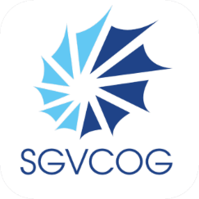
Joint MEETING of the Prop 47 Local Advisory Committee & Community advisory board

AGENDA
Wednesday, April 29, 2026 – 10AM
SGVCOG Office
1333 S. Mayflower Avenue, Suite 360, Monrovia, CA 91016

Jay Alvarado  City of La Verne  Liz Renteria  Tri-City  Ovidio Solis  LA CADA  Lucy Ann Writer  NAMI SGV | Call to Order Joint Meeting of the Prop 47 Local Advisory Committee (LAC) & Community Advisory Board (CAB)  Public Comment  Introduction  LAC Role & Purpose  Program Updates  Evaluation Updates  Interview Topics & Recruitment  Relevant Policies  Adjourn

