**EAST SAN GABRIEL VALLEY**

**SUSTAINABLE MULTIMODAL IMPROVEMENT PROJECT (SMIP)**

**Scope of Work**

**City of Glendora SMIP Phase 1 Work**

***City of Glendora***

***People Movement Project***

**Glendora SMIP Phase 1 Work Project Description**

The City of Glendora’s SMIP Phase 1 Work shall consist of the following – The People Movement Project (i.e., the PROJECT)includes the strategic build out of approximately 9.8 miles of Active Transportation infrastructure. The People Movement Project is comprised of five total Projects including: 1) Glendora Avenue Project, 2) Little Dalton Wash Project, 3) San Dimas Wash Project, 4) Foothill Boulevard Project, and 5) Big Dalton Wash Project which together would deliver key First/Last Mile connectivity improvements to the Metro A Line and fully develop the Glendora Urban Trail System, and are described in detail below. The Urban Trails are Class I multi-use bicycle/pedestrian facilities (bikeways/bike paths) along flood control channels. First/Last Mile improvements include separated bike lanes, curb extensions, roundabout, and a protected intersection.

1. *Glendora Avenue Project*

The Project includes the construction of 0.5-mile of raised Class IV protected bikeway and pedestrian improvements along Glendora Avenue from Glendora Avenue/Foothill Boulevard to Glendora Avenue/Route 66. Project elements also include a protected intersection at Foothill Boulevard/Glendora Avenue, biofiltration curb extensions and enhanced crosswalk at Carroll Avenue/Glendora Avenue, roundabout at Ada Avenue/Glendora Avenue, wayfinding signage, and funding permitted, green street features such as dry wells and tree well filters. In addition, the project will utilize antique street lights that are no longer in operation and currently in City storage. As part of this project the antique street lights will need to be refurbished before installation along Glendora Avenue, between Ada Avenue and Foothill Boulevard. It will also be imperative that this project is coordinated with the separate Glendora Avenue Water and Street Improvement Project (from Gladstone to Route 66) as well as the Foothill Boulevard Project (listed below) in order to mitigate any conflicts and reduce community impacts.

Preparation for Relocation of City Marquee and Traffic Signal Cabinet

The City currently has a digital marquee located on Foothill Boulevard in front of the City Hall entrance. As part of a separate project, the City plans to relocate the marquee to the southeast corner (SEC) of Foothill Boulevard and Glendora Avenue; however, preparation work will be completed as part of this People Movement Project. In preparation for the relocation, conduit will be installed for the marquee's new location. Additionally, conduit will be installed to support the relocation of the traffic signal cabinet at the SEC of Foothill Boulevard and Glendora Avenue approximately 25 to 30 meters south along Glendora Avenue.

1. *Little Dalton Wash Project*

The Project includes the construction of 1.7 miles of Class I bicycle and pedestrian facilities to provide an eight-to-80 facility between the Colby Trail and Finkbiner Park along the Little Dalton Wash from the southern terminus of the Colby Trail located at the end of the cul-de-sac on N. Loraine Avenue/Saga Street to Finkbiner Park located at 160 N. Wabash Avenue (one block north of Foothill Boulevard between Wabash Avenue and Cullen Avenue). This Project also includes street intersection crossing improvements, on-street Class III bike route due to right-of-way constraints, native landscaping, park amenities such as benches, water fountains, and monument signs.

1. *San Dimas Wash Project*

The Project includes the construction of 1.6 miles of Class I bicycle and pedestrian facilities along the San Dimas Wash from Sunflower Avenue/Gladstone Street to Grand Avenue/Arrow Highway. This Project’s components include four street crossing/intersection improvement upgrades including three midblock crossings, one pedestrian scramble, native landscaping, and park amenities such as benches, water fountains, workout equipment, and trail monument signs.

1. *Foothill Boulevard*

The Project includes the construction of 1.48 miles of Class IV protected bikeway and pedestrian improvements along Foothill Boulevard from Citrus Avenue to Minnesota Avenue. Elements include four traffic signal modifications, 16 ADA curb ramps, curb extensions and enhanced sidewalks. If all antique street lights are not utilized with the Glendora Avenue Project, remaining refurbished lights, pending available funding, will be included for installation along Foothill Boulevard. Coordination with the Glendora Avenue segment will be imperative to mitigate any conflicts and reduce community impacts.

1. *Big Dalton Wash*

The Project includes the construction of approximately 4.5 miles of Class I and Class II/IV bicycle facilities and pedestrian improvements along the Big Dalton Wash corridor from Dalton Canyon to Barranca Avenue. The design will prioritize seamless connectivity, safety, and clear directional signage to guide users along the entire route. Special attention will be given to the segment between Foothill Boulevard and Route 66, where the trail will temporarily diverge from the Wash to bypass the City’s Corporate Yard. In this section, the trail will reroute west to Loraine Avenue, proceed south to Route 66, and then reconnect with the Wash, ensuring a continuous and user-friendly experience.

*Glendora SMIP Phase 1 Work Project Limits/Area & Location Map*

1. *Glendora Avenue Project*

The project is located along Glendora Avenue in the City of Glendora. The project limits are Glendora Avenue/Foothill Boulevard to the north and Glendora Avenue/Route 66 to the south.

1. *Little Dalton Wash Project*

The project is located between the Colby Trail and Finkbiner Park along the Little Dalton Wash in the City of Glendora. The project limits are from the southern terminus of the Colby Trail located at the end of the cul-de-sac on N. Loraine Avenue/Saga Street to Finkbiner Park located at 160 N. Wabash Avenue (one block north of Foothill Boulevard between Wabash Avenue and Cullen Avenue).

1. *San Dimas Wash Project*

The project is located along the San Dimas Wash in the City of Glendora. The project limits are from Sunflower Avenue/Gladstone Street to Grand Avenue/Arrow Highway.

1. *Foothill Boulevard*

The project is located along Foothill Boulevard from Citrus Ave to Minnesota Ave.

1. *Big Dalton Wash Project*

The project is located along the Big Dalton Wash from Dalton Canyon Road to Barranca Avenue.

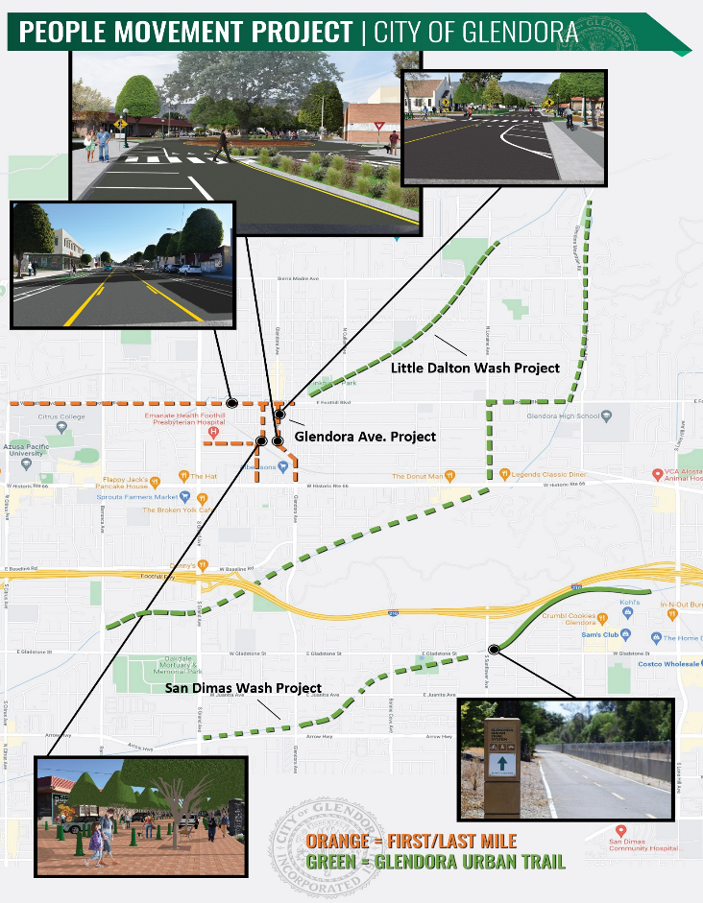

**Glendora People Movement Project Milestone Schedule**

1. *Glendora Avenue Project*

Project Status: The Project is currently at 30% preliminary engineering design.  Next steps include conducting outreach, completing PS&E (final design), and completing California Public Utilities Commission (CPUC) General Order No. 88 for the existing at-grade railroad crossing at Glendora Avenue/Metro A Line.

Project Schedule:  Construction estimated to start in FY2026.

|  |  |  |  |
| --- | --- | --- | --- |
| **Glendora SMIP Phase 1 Project Milestone Schedule** | | | |
| **Project Milestones / Phases** | **Start Date** | **End Date** | **Duration**  **(Months)** |
| PA&ED | April 1, 2025 | December 31, 2025 | 9 |
| PS&E | April 8, 2024 | July 1, 2026 | 27 |
| ROW | n/a | n/a |  |
| CON | October 31, 2026 | October 1, 2027 | 12 |
| CLOSEOUT | November 1, 2027 | February 28, 2028 | 4 |

1. *Little Dalton Wash Project*

Project Status: The Project is currently at 30% preliminary engineering design.  Next steps include conducting outreach, completing PS&E (final design).

Project Schedule:  Construction estimated to start in FY2027.

|  |  |  |  |
| --- | --- | --- | --- |
| **Little Dalton Wash SMIP Phase 1 Project Milestone Schedule** | | | |
| **Project Milestones / Phases** | **Start Date** | **End Date** | **Duration**  **(Months)** |
| PA&ED | April 1, 2025 | December 31, 2025 | 9 |
| PS&E | April 8, 2024 | October 1, 2026 | 30 |
| ROW | July 1, 2025 | April 1, 2026 | 10 |
| CON | January 1, 2027 | Apri 1, 2028 | 15 |
| CLOSEOUT | May 1, 2028 | September 1, 2028 | 4 |

1. *San Dimas Wash Project*

**Project Status:** The Project completed engineering design efforts in February 2025. The SGVCOG is currently working to prepare an Invitation For Bid to secure a contractor to begin construction which is anticipated to begin in by the fall of 2025.

**Project Schedule:** Construction to begin by fall 2025.

|  |  |  |  |
| --- | --- | --- | --- |
| **San Dimas Wash SMIP Phase 1 Project Milestone Schedule** | | | |
| **Project Milestones / Phases** | **Start Date** | **End Date** | **Duration**  **(Months)** |
| PA&ED | December 1, 2018 | March 18, 2019 | ½ |
| PS&E | March 22, 2022 | September 30, 2024 | 30 |
| ROW | June 1, 2023 | September 30, 2023 | 4 |
| CON | October 31, 2025 | November 1, 2026 | 12 |
| CLOSEOUT | December 1, 2025 | March 31, 2026 | 4 |

1. *Foothill Boulevard Project*

Project Status: The Project is currently at 10% conceptual engineering design.  Next steps include conducting outreach, completing 30% preliminary engineering, and PS&E (final design).

Project Schedule:  Construction estimated to start in FY2027.

|  |  |  |  |
| --- | --- | --- | --- |
| **Foothill Boulevard SMIP Phase 1 Project Milestone Schedule** | | | |
| **Project Milestones / Phases** | **Start Date** | **End Date** | **Duration**  **(Months)** |
| PA&ED | January 1, 2025 | September 30, 2025 | 9 |
| PS&E | December 2, 2024 | July 1, 2026 | 19 |
| ROW | n/a | n/a |  |
| CON | October 1, 2026 | October 1, 2027 | 12 |
| CLOSEOUT | November 1, 2027 | March 1, 2028 | 4 |

1. *Big Dalton Wash Project*

Project Status: The Project is has not been formally initiated.

Project Schedule:  Design estimated to start by June 2025.

|  |  |  |  |
| --- | --- | --- | --- |
| **Big Dalton Wash SMIP Phase 1 Project Milestone Schedule** | | | |
| **Project Milestones / Phases** | **Start Date** | **End Date** | **Duration**  **(Months)** |
| PA&ED | October 1, 2025 | July 1, 2026 | 9 |
| PS&E | June 1, 2025 | May 31, 2027 | 24 |
| ROW | January 1, 2026 | October 30, 2026 | 10 |
| CON | July 1, 2027 | July 1, 2028 | 12 |
| CLOSEOUT | August 1, 2028 | December 1, 2028 | 4 |