2023-2024 SGVCOG Food Recovery Hub Grant Program Application

Food Recovery Hub Grant Program
Application Deadline | June 1, 2023, 11:59 PM
Number of Awards Anticipated | Approximately 1-3 awards
Total Amount Available | $190,000.00

Background

Under Senate Bill 1383, edible food generators (EFGs) such as food wholesalers, supermarkets, and restaurants, must donate surplus food to be recovered for human consumption. This increased donation necessitates expanded capacity at food recovery organizations (FROs), food recovery services (FRSs), food pantries and feeding sites in order to receive and manage the additional food. Additionally, large edible food donations can be challenging for non-proﬁts to accept and redistribute in manageable quantities. Practices for safe food handling and proper disposal of food waste must be implemented. To meet existing and future requirements, coordinated eﬀorts that allow for collaborative solutions for additional resources to collect, transport, and store surplus food are needed.

Opportunity

The San Gabriel Valley Council of Governments (SGVCOG) seeks to award funding to assist in the development of food recovery hubs (Hubs) that will expand regional food recovery eﬀorts to recover additional surplus food for distribution and/or redistribution to smaller organizations and community members facing food insecurity.

The SGVCOG anticipates developing 1-3 surplus food redistribution Hubs. The objective is to facilitate recovery of food from EFGs in the participating cities, and provide food to people who live in, and nearby, those cities.
Ultimately the entire region would have access to the Hubs, either upon launch or future expansion, with increased development of networks that redistribute surplus food throughout the San Gabriel Valley (SGV).

The cities participating in the Hub project are grouped into the following regions: Region 1: La Cañada-Flintridge, Monterey Park and San Gabriel
Region 2: Baldwin Park, Duarte, Irwindale, and Monrovia
Region 3: Azusa, Covina and Glendora
Additional cities may join in the near future.

Minimum Eligibility Criteria

To be eligible for a grant, applicants must meet the minimum mandatory requirements (MMR):

- Food recovery organization (FRO) or food recovery service (FRS) currently collecting, or with the ability to collect food from edible food generators (EFGs) in at least one of the regions of the SGV (as noted in the Opportunity section), and
- Tax-exempt organization under Section 501(c)(3) of the Internal Revenue Code OR be ﬁscally sponsored by a 501(c)(3) OR partner with a 501(c)(3) as the lead applicant, and
- Experience in surplus food recovery/redistribution, and
- Commitment to partner with the SGVCOG, local FROs/FRSs, pantries and feeding sites to support existing programs and potential connections to other related programs.

Eligible Activities

Applicants must demonstrate their ability to engage in activities that foster the creation and management of a Hub. For the purposes of this grant, a Hub may consist of, but is not limited to:

- A physical storage location (such as warehouse), inclusive of refrigerated and unrefrigerated storage
- Multiple physical locations linked by shared technology and managed either by the same or diﬀerent non- proﬁts in partnership
- A coordination and/or transportation service that matches pantries to available food and transports that food directly from EFGs to dispersed locations

Regardless of the model, a Hub’s activities should enable the eﬀicient redistribution of surplus food and build/enhance a regional system.

Required Activities

- Increase the capacity to recover edible food
- Increase the recovery of currently disposed edible food
- Create and manage a Hub as identiﬁed in the “Eligible Activities” above
- Expand existing, and forge new, relationships with local EFGs
- Execute written contracts with EFGs
- Collect, weigh (and store) incoming edible food (e.g. packaged, prepared and/or fresh food)
- Record the weight of food collected speciﬁc to the Hub and report to jurisdictions in compliance with SB 1383 requirements.
- Accept requests from, provide food to, and collaborate with smaller organizations
- Accept large donations and divide into manageable portions for distribution
- Promote resource-sharing and collaboration with other organizations
- Facilitate diversion from landﬁlls of spoiled/inedible food

Optional Activities

- Help small non-proﬁts make physical and technological improvements that allow them to accept, store, and distribute more food safely, with less food wasted
- Feed community members directly
- Recover prepared food

Eligible Use of Funds

Funds must be allocated for the creation of one or more hubs. Allowable uses of funds include, but are not limited to:

- Equipment and Supplies (i.e., pallet jack, refrigeration, shelving, vehicles)
- Facility (i.e., improvements, leasing)
- Staﬀ Salaries (up to 50% of grant award)
- Technology (i.e., computers, software, apps)
- Training (i.e., safe food handling certiﬁcations)

Ineligible Use of Funds
- Purchase of food
- Grant writing
- Purchase or lease of land or buildings

Dates and Deadlines

Request for Proposals Announced: May 2, 2023
Optional Virtual Informational Session: May 10, 2023 at 11 AM
Questions due to SGVCOG: May 16, 2023 by 5 PM
Answers to Questions: May 19, 2023
Proposals Due: June 1, 2023 by 11:59 PM
Awardees Announced: Mid-June 2023 (Tentative)
Contract/Notice to Proceed: July 2023 (Tentative)
Eligible Program Cost Expended: March 31, 2024

How To Apply

The SGVCOG held an informational session on Wednesday, May 10, 2023 at 11 AM. Click Here to view the recorded informational session.
- After registering, you will receive an email conﬁrmation with information on how to join the meeting.
- You may submit questions not covered during the session by emailing Mackenzie Bolger at mbolger@sgvcog.org.

Application Instructions
- Answers to all application questions are required for consideration.
- Joint Applications may be submitted if multiple organizations believe a partnership will enhance their ability to provide regional coverage. If submitting jointly, a lead applicant must be speciﬁed.
- Submit applications and supporting documents using SurveyMonkey. All supporting documents should be submitted as attachments.
- Once your application has been submitted, you may request a copy of your responses.

Project Review Process

SGVCOG staﬀ will review submitted applications in accordance with the application criteria, determine applicant’s ability to create and potentially sustain and replicate a Hub that increases regional surplus food redistribution.

Scoring Criteria

Organization Information = 10 points available
Existing Food Redistribution Program = 30 points available
Hub Vision = 30 points available
Alignment with Project Objectives/Outcomes = 30 points available

Total of 100 points available

About San Gabriel Valley Council of Governments (SGVCOG)

The San Gabriel Valley Council of Governments (SGVCOG) is a regional government planning agency that aims to maximize the quality of life in the San Gabriel Valley. We are a joint powers authority that is consisted of 31 incorporated cities, unincorporated communities in Los Angeles County Supervisorial Districts 1, and 5, and three San Gabriel Valley Municipal Water Districts (San Gabriel Valley Municipal Water District, Three Valleys Municipal Water District, and Upper San Gabriel Valley Municipal Water District).

Organization Information

2023-2024 SGVCOG Food Recovery Hub Grant Program Application
The Hub grant program is designed to assist in the development of 1-3 surplus food redistribution Hubs that will facilitate recovery of food from EFGs in the participating cities, and provide that food to people who live in, and nearby, those cities. Ultimately the entire region would have access to the Hub(s), either upon launch or future expansion, with increased development of networks that redistribute surplus food throughout the San Gabriel Valley (SGV).

We invite you to apply to develop and operate one or more Hubs in the SGV.

By submitting this application, you are conﬁrming that all the information provided is accurate.

* 1. Lead Applicant Contact Information

Name

Address

Address 2

City/Town State/Province
ZIP/Postal Code

Email Address

Phone Number

Questions 2-9 are in relation to the lead applicant's organization:

- 2. Are you a food recovery organization?

- 3. Are you a food recovery service?

- 4. Are you a tax-exempt organization under Section 501(c)(3)?

- 5. Number of years operating in the food recovery arena:

- 6. Number of full-time employees:

- 7. Number of part-time employees:

- 8. What is your organization mission and vision? (100 words max)

- 9. Links to your websites & social media:

- 10. Joint Applicant Contact Information (if applicable)

Name

Address

Address 2

City/Town State/Province
ZIP/Postal Code

Email Address

Phone Number

Questions 11-18 are in relation to the joint applicant's organization (if applicable):

- Are you a food recovery organization?

- Are you a food recovery service?

- Are you a tax-exempt organization under Section 501(c)(3)?

- Number of years operating in the food recovery arena:

- Number of full-time employees:

- Number of part-time employees:

- What is your organization mission and vision? (100 words max)

- Links to your websites & social media:

Existing Food Redistribution Program

2023-2024 SGVCOG Food Recovery Hub Grant Program Application

- 19. Describe activities and prior accomplishments related to food recovery and/or redistribution of surplus food. (300 word max)

- 20. Describe existing infrastructure and capacity to recover and distribute food. (400 words max.) Please include the following information:

Food supply chain transportation, equipment, logistics Storage and handling capabilities
Written Agreements with EFGs Record-keeping

- 21. What's your organization’s operating budget for the previous year speciﬁc to the collection and distribution of recovered food? (Please note if this amount includes overhead, additional operations, or purchased food)

- 22. Provide a list of EFGs from which you currently collect food within the SGV.

- 23. Provide a list of your partner FROs, food banks, feeding sites and pantries within the SGV.

- 24. What's your pickup/delivery frequency from/by EFGs monthly?

- 25. What's your pickup/delivery frequency to/by other FROs, feeding sites and pantries monthly?

- 26. What's the number of distributions to community members directly managed by your organization/number of people served monthly?

- 27. What's the amount of recovered food delivered to pantries/feeding sites or directly to community members in lbs. per month (if you use meals as a metric, 1 meal equals 1.2 lbs.)?

- 28. What are the types of food you collect?

- 29. How many additional lbs. of food per month do you have the capacity to recover?
- The cities participating in the Hub project are grouped into three regions.

30. For the below cities that are participating in the program, please check all that apply:

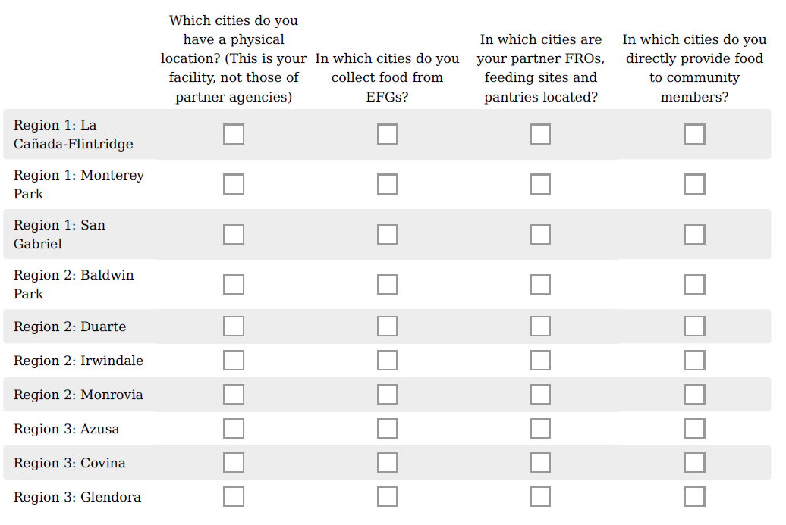
- For the below cities that are not currently participating in the Hub program, please check all that apply:

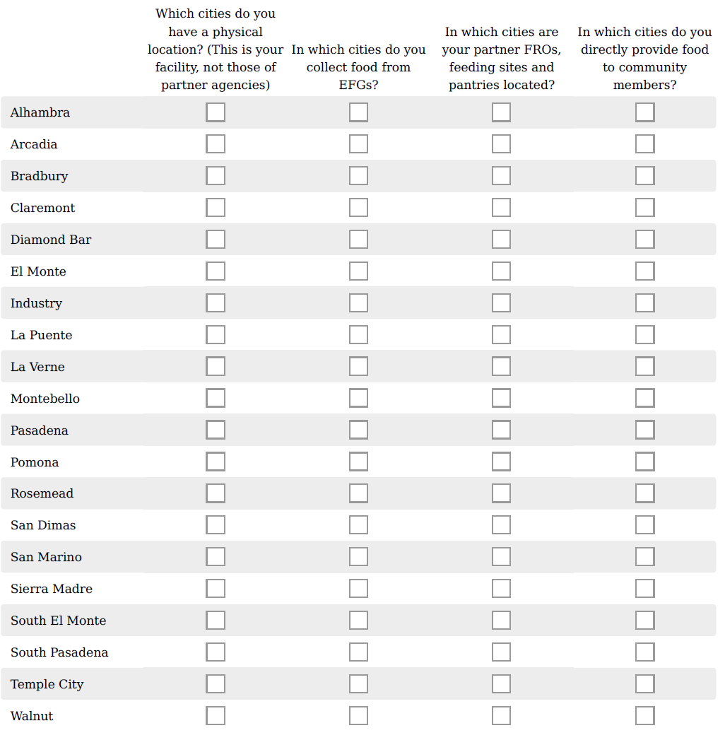

- Please list all cities outside of SGV that you have the following:
In which cities do you have a physical location? (This is your facility, not those of partner agencies.)

In which cities do you collect food from EFGs?

In which cities are your partner FROs, feeding sites and pantries located?

In which cities do you directly provide food to community members?

HUB Vision and Outcomes

2023-2024 SGVCOG Food Recovery Hub Grant Program Application

* 33. Describe your vision of a Hub and how it will increase regional capacity to collect and distribute food. Include project goals and what success looks like. Please include the following if applicable (we understand that these are goals, not certainties). (500 words max)

- Tons of food recovered (Note: that the grant’s intention is to increase not maintain the amount of food already recovered so this amount should not include edible food already being recovered through your current operations)
- Type of food recovered (packaged, produce, prepared)
- Nutritious food vs. empty calories (e.g., soda, candy)
- EFG partnerships
- Pantry/Feeding Site/FRO relationships
- Communities served
- Expansion of regional food recovery network cooperation

- 34. The SGVCOG will be able to provide some technical assistance, such as matching with EFGs, executing contracts, obtaining software, etc. What sort of support might prove helpful to support your hub? (200 word max)

- 35. In your vision of a hub, what innovative solutions would you put in place to recover more food (e.g., not usual, routine or established practices) ? (200 word max)

- 36. What challenges do you foresee with establishing and maintaining the Hub? (200 word max)

- 37. If partnering with another FRO/FRS, explain how this relationship will beneﬁt the project. (200 word max)
- 38. The cities participating in the Hub project are grouped into three regions.

For the below cities that are participating in the program, please check all that apply:

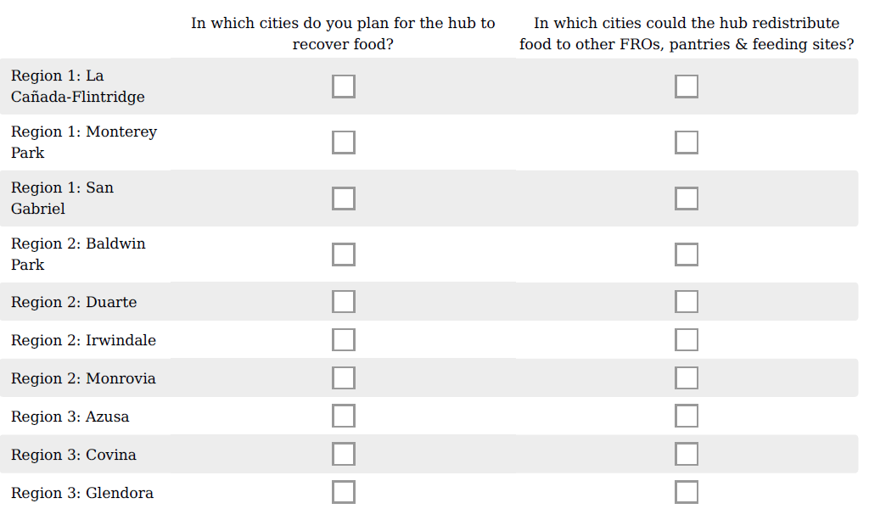
39. For the below cities that are not currently participating in the Hub program, please check all that apply:

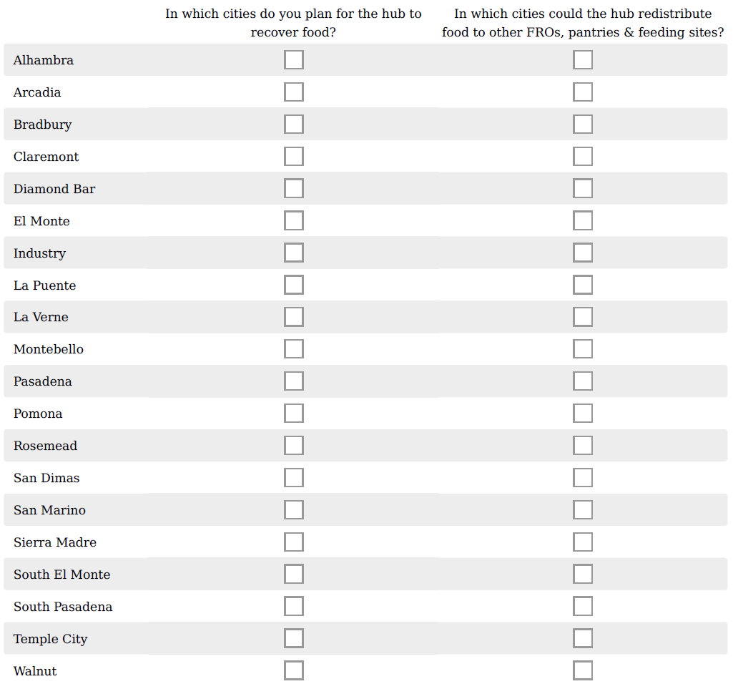
- 40. How will your organization leverage existing and additional resources? (300 word max)

- 41. How much funding are you requesting, what will it pay for, and how will it support your hub vision? Please provide a narrative. (500 word max)

- 42. How much funding are you requesting and what will it pay for? Please ﬁll in the grid with speciﬁc items and costs for each category.
For expenses over $5,000, please attach a quote in question 43.

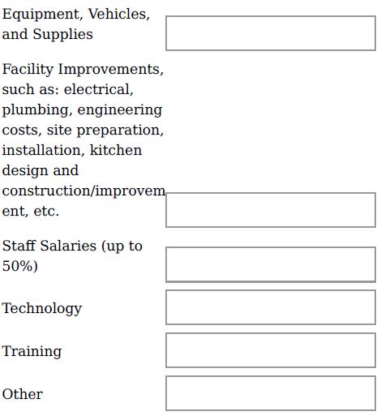

43. Provide quote for expenses over $5,000.

Reporting Requirements

2023-2024 SGVCOG Food Recovery Hub Grant Program Application

* 44. Reporting will need to satisfy the requirements of California SB 1383 as well as provide metrics that allow the SGVCOG to evaluate the program’s success and possible expansion.

Will you be able to provide all the following information on a quarterly basis?

Tons of food collected from each EFG (separate from any existing tonnage collected by your food recovery operation)
Type of food (e.g., meat & seafood, packaged goods, produce, etc.) collected from each EFG
List of new and expanded EFG relationships with addresses
List of new and expanded distribution to organizations/pantries with addresses
List of new direct-to-community distribution sites with number of individuals served
Support provided to smaller organizations/pantries (if any)
Additional resources needed to sustain/grow eﬀorts past the initial grant period.

45. Please share any concerns or issues with reporting on the above information.

